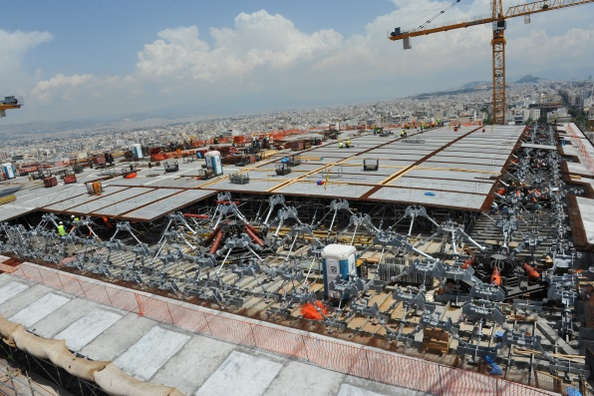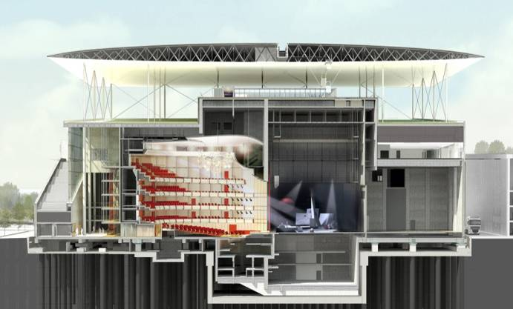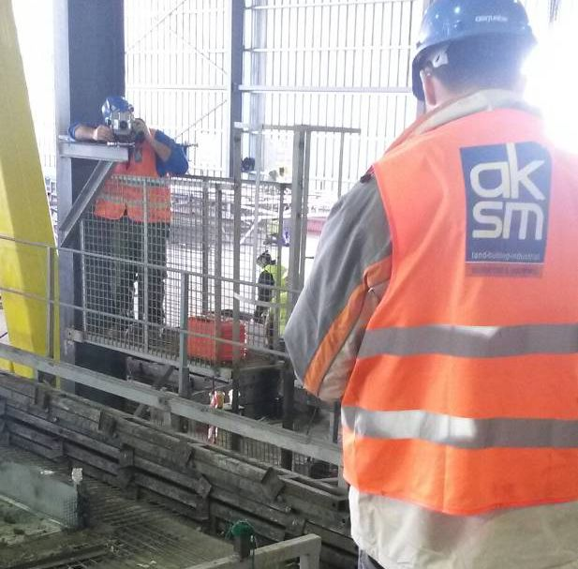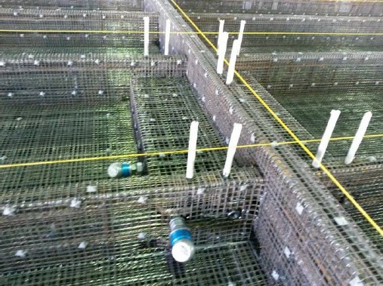

6

The ferrocement canopy of the opera building is made out of two ferrocement skins: the superior one (top skin) and the interior one (bottom skin). They are connected together by ferrocement diaphragms and steel diagonal circular hollow tube sections. Each skin consists of different ferrocement panels casted into steel formworks during the canopy preconstruction phase. The general methodology, for the canopy, envisaged foresees the preconstruction on the ground of 6875x3173mm (typical prefabricated panel dimension) precast elements corresponding to parts of the bottom and top skin of the canopy that will be connected with splice zones at the final canopy position which have equal dimensions of 577mm between the ribs.

* PRECONSTRUCTION

Each ferrocement panel is casted on metal formwork (4000x800) installed on metal benches. It consists of a thick steel plate (t=10mm), that is made rigid with upn sections, is leveled and is connected via stiffeners to turnbuckles which allow the creation of the exact curvature for each panel. The steel plate is controlled by 64 points that correspond to the panels geometry. Deformations and deflection on the surface at the plate were adjusted accuracy leveler and invar rod.

Subsequent to the surface adjustment, the panel’s reinforcement was placed on the casting mould. The reinforcement was placed on the mould in a way that is constructed ribs and beams axes to perfectly match the theoretical axes that had been set out to the casting table. Correction movements were performed in order to eliminate deviations, by investigating the position of the implemented to the reinforced couplers. First the 28 mm skin was casted. Then by screw adjusted side would were used in order to cast the ribs, the beams and thickenings.

Reflective targets mounted on steel plates, placed on side would were used in order to verify the alignment on ribs and beams.

Finally control points were installed on the inner side of the panel and on the external visible side to be used during the erection sequence via the transformation from Local (preconstruction) to Global (erection) reference system.

CASE STYDY The SNFCC ferrocement Canopy construction & erection

INDUSTRIAL SURVEYING

3

INDUSTRIAL SURVEYING

3

3

3

WFGT Unit at Unit III of PPC S.A, Megalopolis

Surveying Precision

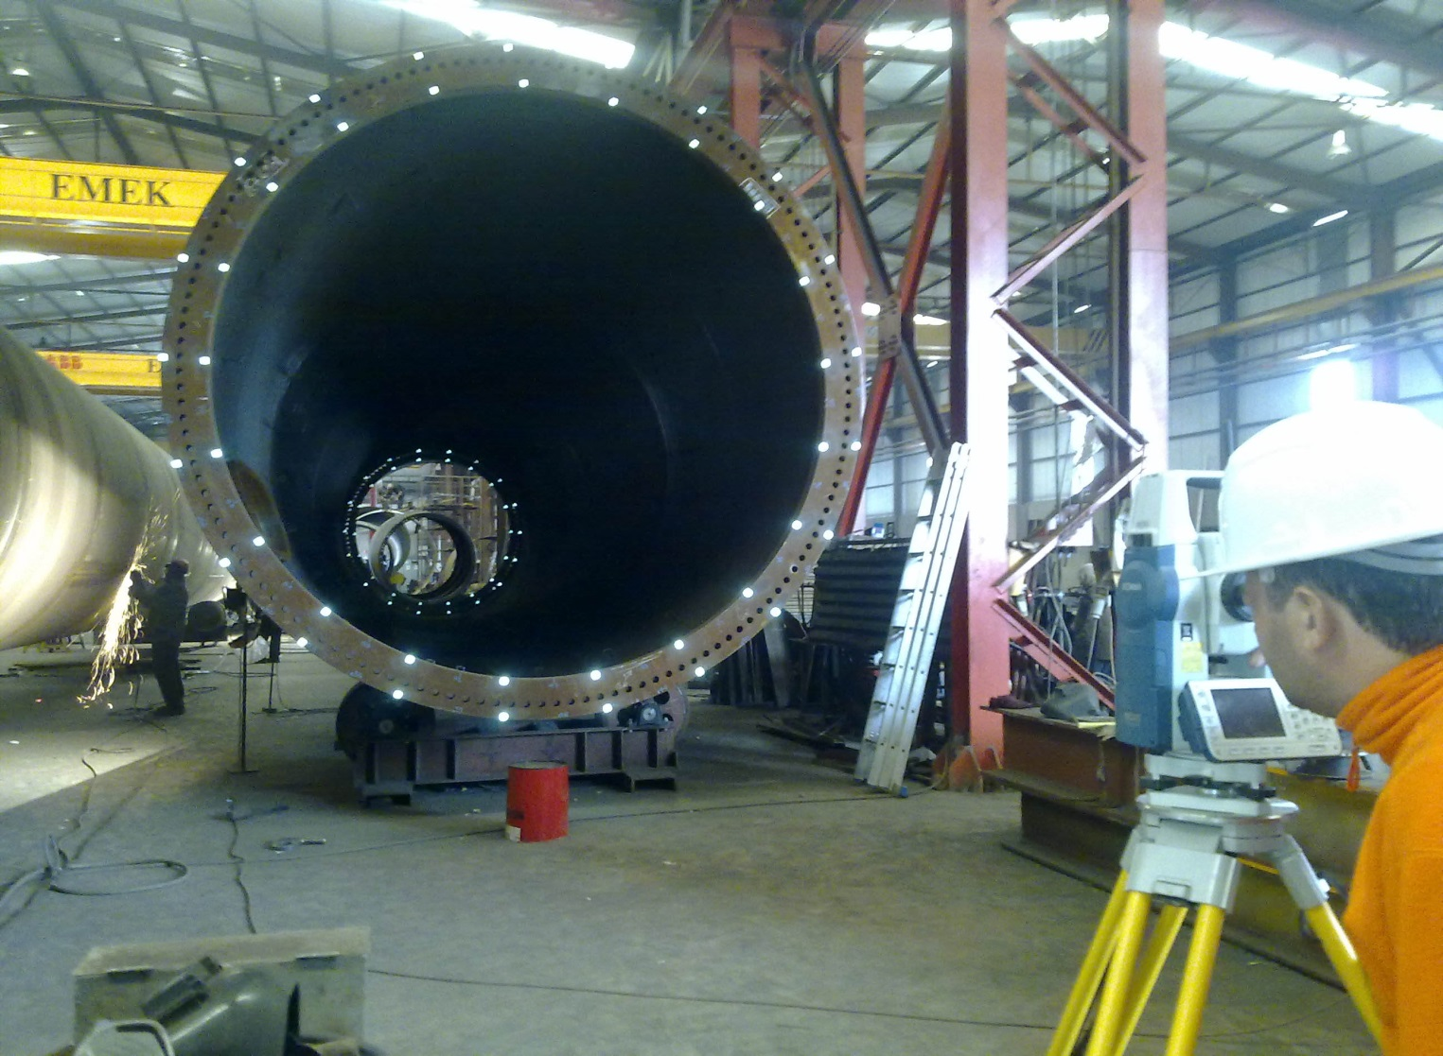

3

High Pressure Natural Gas and Regulating Station, Tema, Ghana

3

3

INDUSTRIAL SURVEYING

INDUSTRIAL SURVEYING

3



5

5

www.aksm.gr

3

Industrial

Surveying

**SURVEYING PRECISION**

INDUSTRIAL SURVEYING

E-mail: info@aksm.gr